Semester One Examination, 2022

Question/Answer booklet

MATHEMATICS SPECIALIST
UNIT 3

Section Two:

Calculator-assumed

Your Name

Your Teacher’s Name

Time allowed for this section
Reading time before commencing work: ten minutes
Working time: one hundred minutes

Materials required/recommended for this section
To be provided by the supervisor
This Question/Answer booklet
Formula sheet (retained from Section One)

To be provided by the candidate
Standard items: pens (blue/black preferred), pencils (including coloured), sharpener, correction fluid/tape, eraser, ruler, highlighters

Special items: drawing instruments, templates, notes on two unfolded sheets of A4 paper, and up to three calculators approved for use in this examination

Important note to candidates
No other items may be taken into the examination room. It is your responsibility to ensure that you do not have any unauthorised material. If you have any unauthorised material with you, hand it to the supervisor before reading any further.
Question | Marks | Max | Question | Marks | Max
9 |  | 7 | 16
10 |  |  | 17
11 |  |  | 18
12 |  |  | 19
13 |  |  | 20
14 |  |  | 21
15

Structure of this paper

Section | Number of questions available | Number of questions to be answered | Working time (minutes) | Marks available | Percentage of examination
Section One:  Calculator-free | 8 | 8 | 50 | 52 | 35
Section Two:  Calculator-assumed | 14 | 14 | 100 | 97 | 65
 |  |  |  | Total | 100

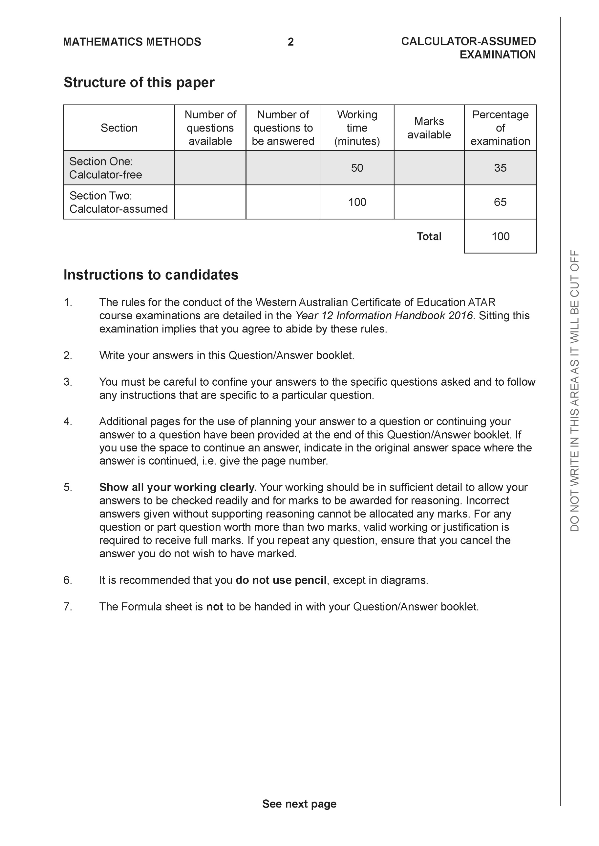

Section Two: Calculator-assumed (97 Marks)

This section has 14 questions. Answer all questions. Write your answers in the spaces provided.

Spare pages are included at the end of this booklet. They can be used for planning your responses and/or as additional space if required to continue an answer.
● Planning: If you use the spare pages for planning, indicate this clearly at the top of the page.
● Continuing an answer: If you need to use the space to continue an answer, indicate in the original answer space where the answer is continued, i.e. give the page number. Fill in the number of the question that you are continuing to answer at the top of the page.

Working time: 100 minutes.

Question 9 (7 marks)

Consider the complex numbers plotted on the Argand plane below.

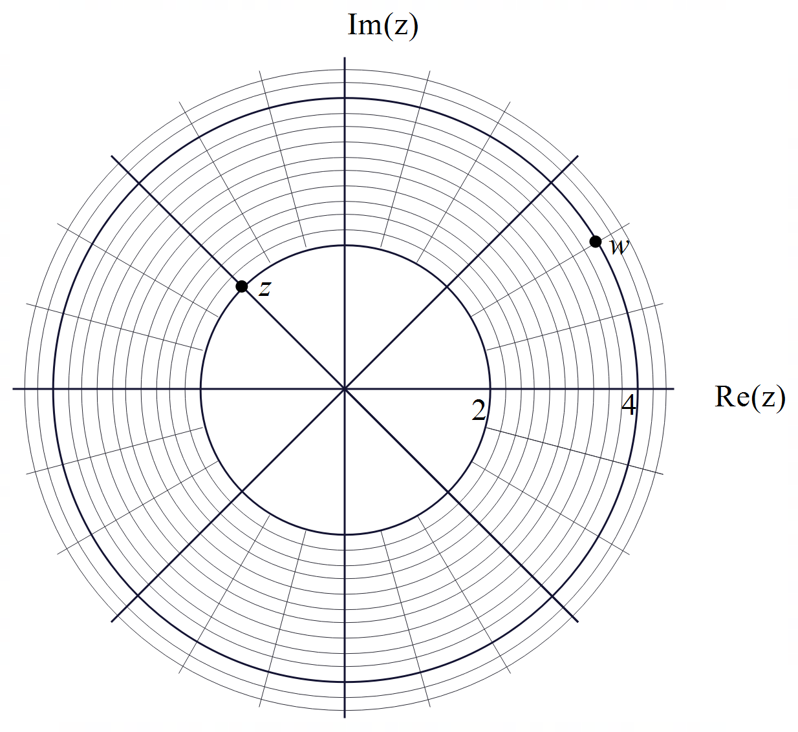

- Express in polar form with principal argument. (2 marks)

- Express in cartesian form. (2 marks)

- Plot on the axes above. (3 marks)

Question 10 (10 marks)

Consider the region shaded in the Argand plane below.

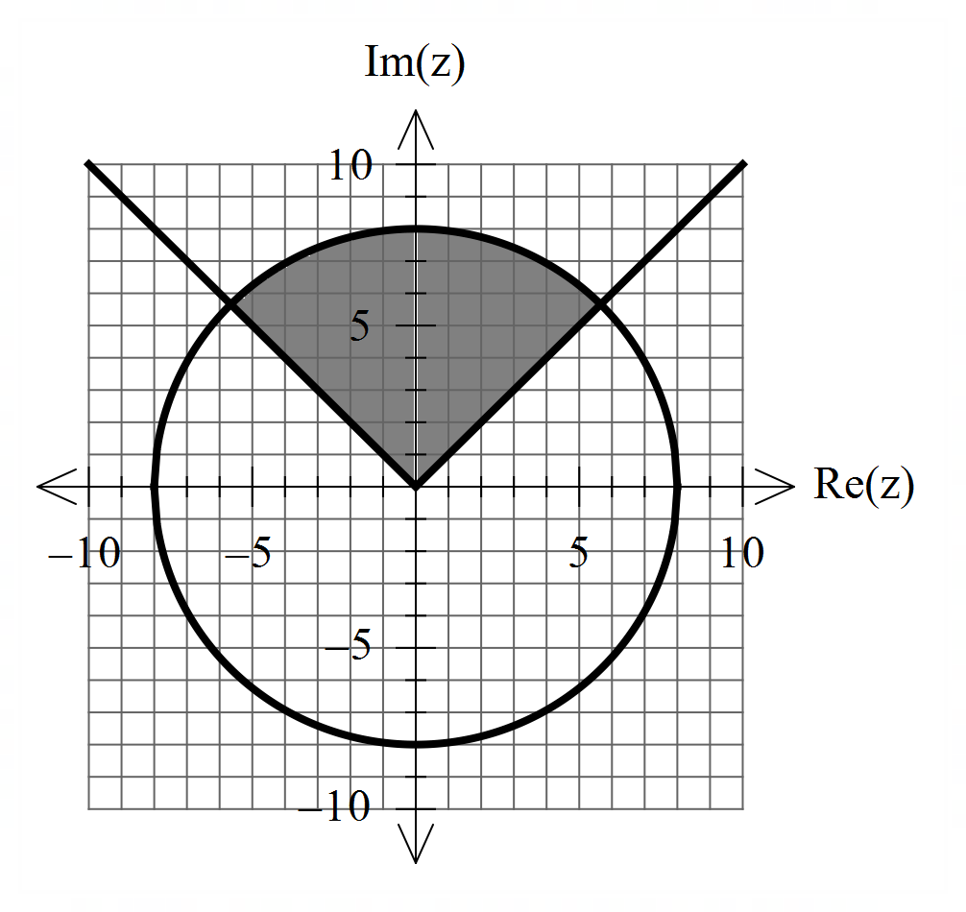

- In terms of , describe the region of complex numbers shaded above. (4 marks)

- i) Sketch the locus such that on the Argand plane above. (3 marks)

ii) Determine the maximum value of Arg() (3 marks)

Question 11 (8 marks)

Consider a rectangular prism ,as shown below, with

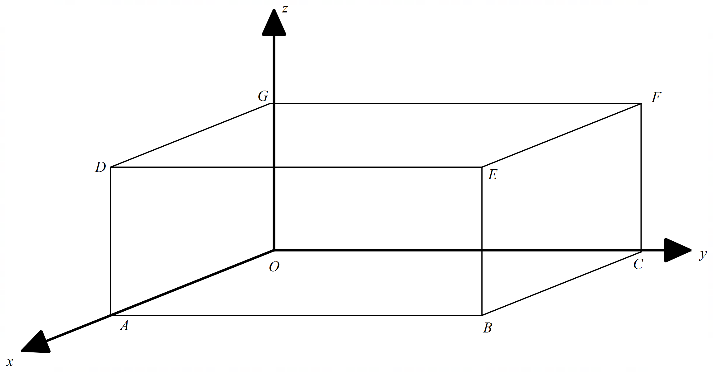

- Prove that the diagonals bisect each other using vector methods. (4 marks)

Q11 continued-
- Determine the exact vector equation of a sphere that goes through all vertices of the rectangular prism . (4 marks)

Question 12 (9 marks)

Consider rockets that are ignited at the same times from the following positions and constant velocities. (At time )

- Prove using vector methods that the two rockets do not meet. (3 marks)

- Determine the closest approach between the two rockets using vector methods.
(4 marks)

Q12 cont-

- At time hour, rocket will change its velocity so that it will collide with rocket at time hours. Determine this new constant velocity of rocket to 2 decimal places.
(4 marks)

Question 13 (6 marks)

Consider the line and the point .
- Determine the distance of point to the line using vector dot product. (3 marks)

- Determine the distance of point to the line using vector cross product. (3 marks)

Question 14 (7 marks)

Consider the plane which contains the line A, and the parallel plane which contains the line B, as shown in the diagram below, (not drawn to scale).
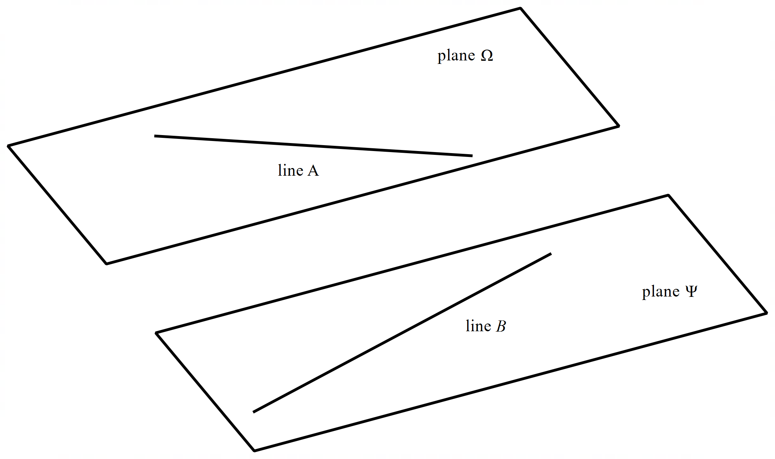

- Determine the cartesian equation of plane (3 marks)

- Determine the distance between the two planes. (4 marks)

Question 15 (6 marks)
Let where .
- Determine an expression for in terms of only. Simplify. (3 marks)

- Determine an expression for in terms of only. (3 marks)

Question 16 (9 marks)

- Determine the roots to in the form with . (4 marks)
Q16 continued-
- Plot the roots from part a on the axes below. (2 marks)

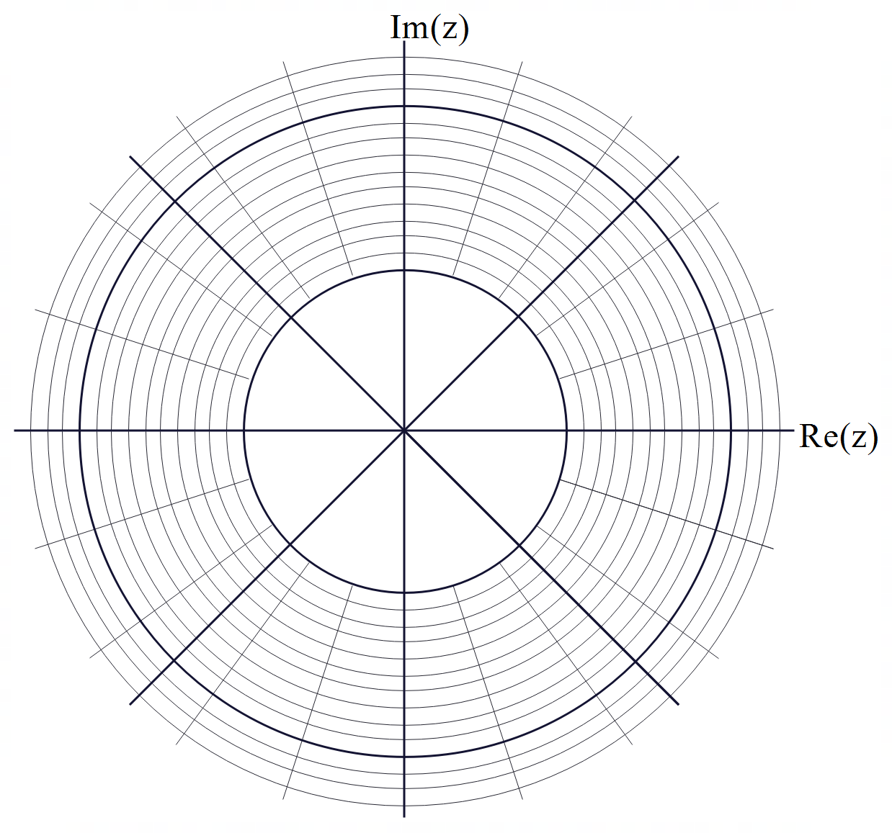

- The roots above form a polygon, determine the perimeter of this polygon.
(3 marks)

Question 17 (3 marks)

Consider the locus of points that satisfy . Describe this locus identifying all major features.

Question 18 (7 marks)

Consider the line , is a constant and the sphere .
Determine all possible values of using vector methods such that:
- The line is a tangent to the sphere.
- The line passes through the sphere.
- The line misses the sphere completely.

Q18 continued-

Question 19 (4 marks)

Simplify showing all reasoning.

Question 20 (4 marks)

Consider .
- Show that where is a positive integer. (3 marks)

- Determine the positive integer values of such that (1 mark)

Question 21 (9 marks)

Consider the following system of linear equations.

- Show without the use of a classpad, that there are infinite solutions. (3 marks)

- Give a geometric interpretation to the solution above. (1 mark)

- Determine a vector equation for all solutions. (3 marks)

- If there is the restriction , determine the range of values for . (2 marks)

Question 22 (8 marks)

Consider a projectile fired from a toy gun which moves at a constant velocity and rebounds off a plastic flat board with its speed unchanged. See diagram below.

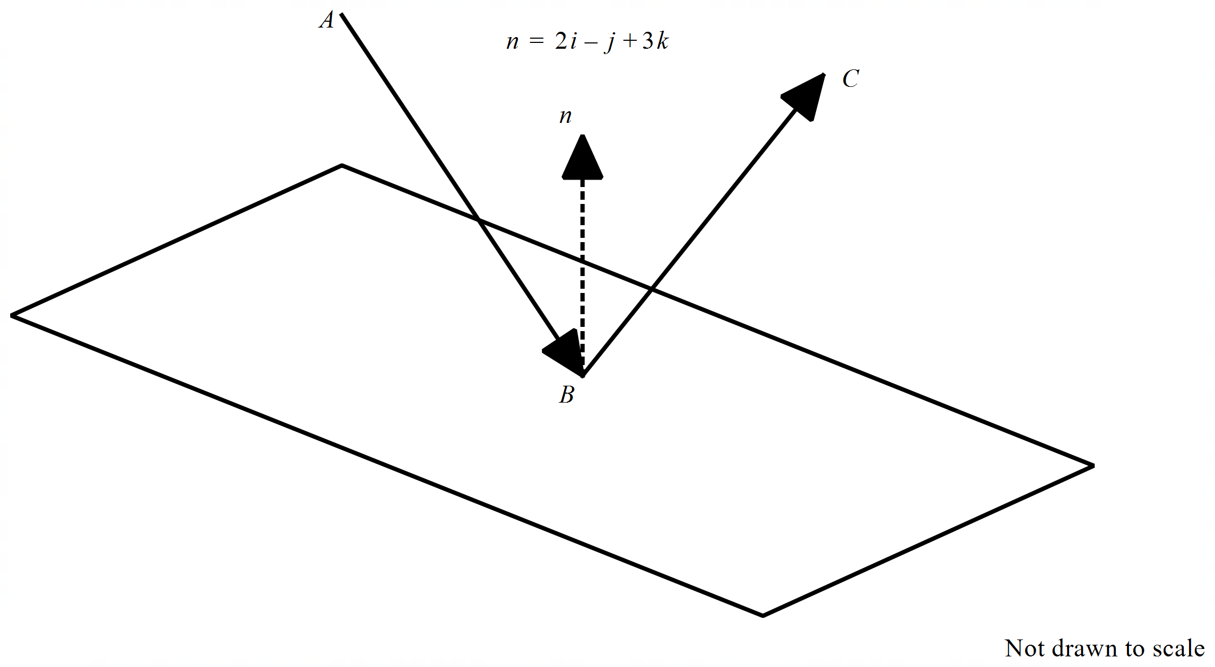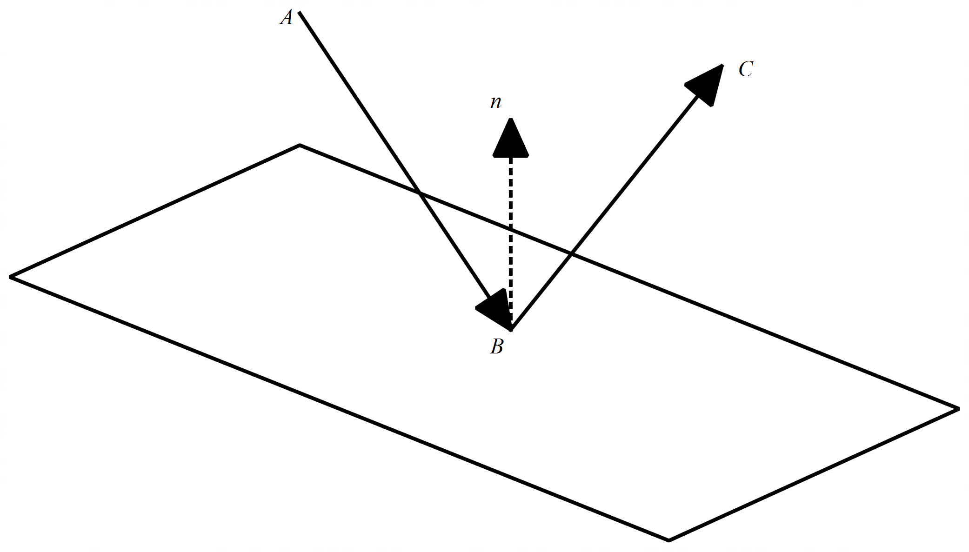

The projectile moves in the direction and rebounds in the direction with the same speed. The flat board has the equation . The angle of the incoming path and the normal is equal to the angle of the outcoming path and the normal. Both paths &and the normal exist in the same plane.

Determine the velocity of the reflected projectile and the angle with the above normal to 2 decimal places.

Q22 continued-

Working out space

Working out space
Working out space

